Mantid
PM report to Project Management Board
13th March 2013
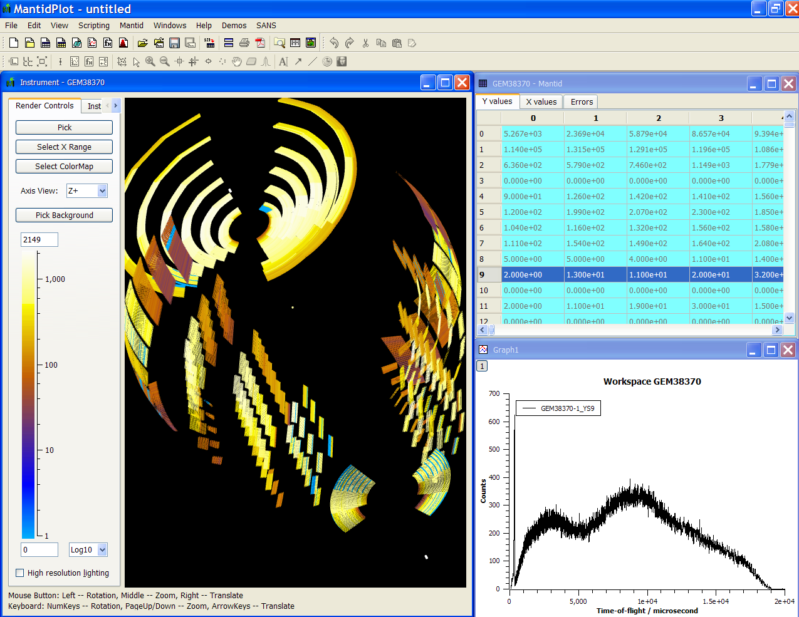
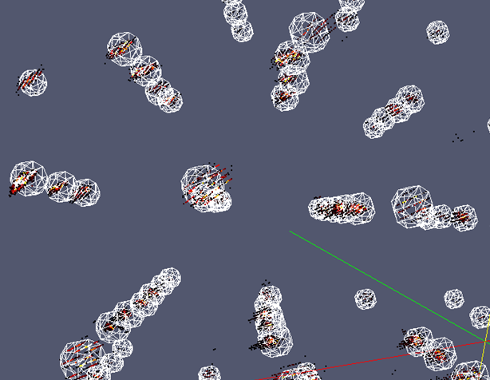
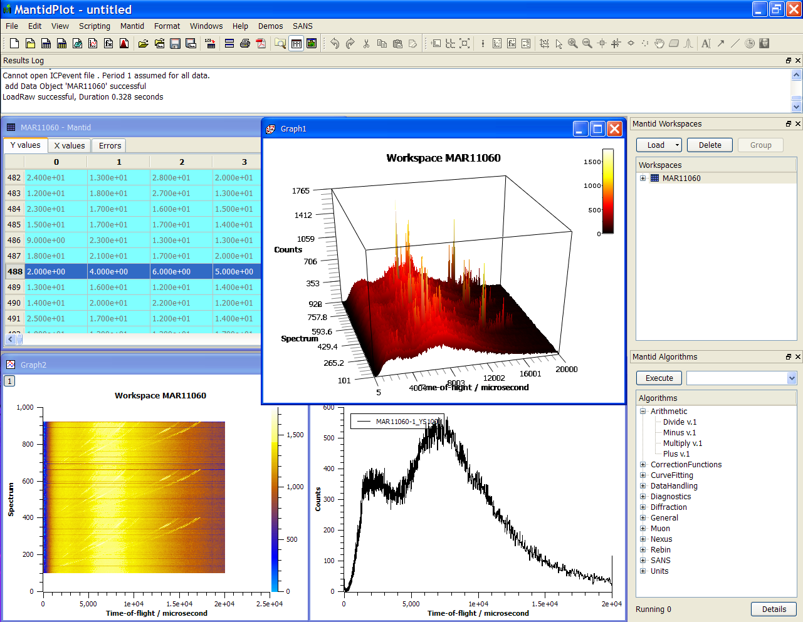
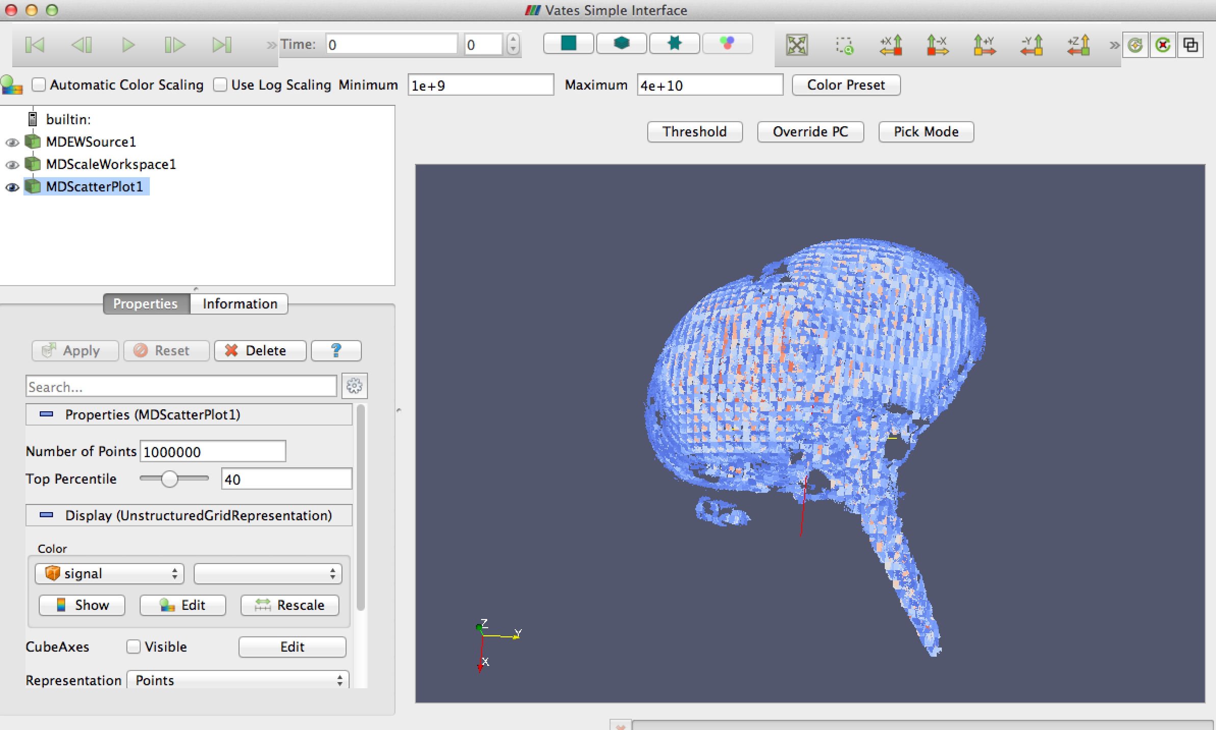
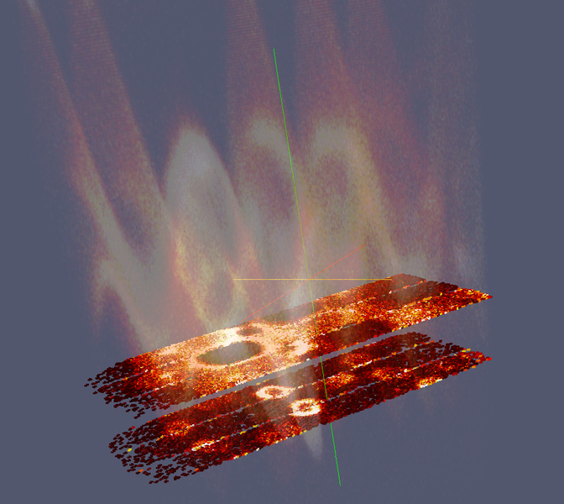
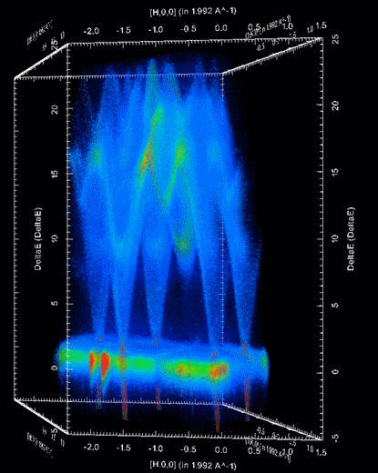

Document Control
This document is under document control. All members of the distribution list will receive updated copies whenever alterations are made. All other copies are uncontrolled.

Contributors
Name | Role | Company
Nicholas Draper | Author | Tessella

Document Approval
Name | Role | Company

Distribution
Name | Role | Company
Project Management Board Members | Recipient | STFC & ORNL
Mantid Project Repository | Filing | STFC & ORNL

Revision History
Author | Issue | Date | Description
Nicholas Draper | V1.R1.M0 | 30-Sep-2013 | 1st version written

References
Document | Ref | Date | Details and Version
Project Specification | [PS] |  | https://github.com/mantidproject/documents/blob/master/Project%20Management/ProjectSpecification.doc?raw=true
Stakeholder Plan | [SP] |  | https://github.com/mantidproject/documents/blob/master/Project%20Management/StakeholderPlan.doc?raw=true
Risk Register | [RR] |  | https://github.com/mantidproject/documents/blob/master/Project%20Management/RiskRegister.xls
Mantid Paper Draft |  |  | https://github.com/mantidproject/documents/blob/master/MantidPaper/Mantid.pdf?raw=true
Open Source Governing Model Proposal |  |  | https://github.com/mantidproject/documents/blob/master/Project%20Management/PMB/Open%20Source%20Scatering%20Software%20Governance%20Model.doc?raw=true

Table of Contents
1 Introduction 5
1.1 Purpose of this Document 5
1.2 Scope of this Document 5
1.3 Context of this Issue 5
2 Minutes of the previous meeting 5
3 Project Documentation 5
3.1 Stakeholder Plan: 5
3.2 Risk Register: 5
4 Project Status 6
4.1 Development Progress 6
5 Changes to supported Operating Systems 6
5.1 Mac OS X Snow Leopard 6
6 Referencing Mantid, DOIs and the approval of the Mantid Paper 6
6.1 Mantid Paper 6
6.2 Digital Object Identifiers (DOIs) 7
6.3 Referencing Mantid 7
7 Mantid Governance model 7
8 Steering team meeting and develop meeting planning and approval 8
8.1 Meetings 8
8.2 Proposed Agenda 8
8.3 Travel and hospitality arrangements 9
8.4 Inviting collaborators and interested parties to the Developer Worksop 9
9 Update on interest from other facilities, and existing collaborations 10
9.1 ILL 10
9.2 J-Parc 10
9.3 ANSTO 10
9.4 ESS 10
9.5 China Institute of Atomic Energy 10
9.6 PSI 10
10 Future Release Dates 11
11 Appendix A 12
11.1 Project Metrics 12
11.2 Ticket completion rate 13
11.3 Project Uptake 14

Introduction

Purpose of this Document
This report details the current state of the Mantid project and presents the agreed agenda for discussion. The project management board will use the information in this report as a basis for the meeting.

Scope of this Document
The scope of this document is limited to the Mantid project, both for progress up to the meeting of the Project management board, and plans for the future.

Context of this Issue
This is the tenth project management report to the Mantid project management board and will provide input to the meeting.

Minutes of the previous meeting
The minutes of the previous meeting are available here:
https://github.com/mantidproject/documents/blob/master/Project%20Management/PMB/Minutes/ PMBMinutes15thMar13.docx?raw=true

Project Documentation
The project documentation is available through the links below. The Risk Register has been reviewed and updated. The other documents have not been changed since the last PMB meeting.

Stakeholder Plan:
https://github.com/mantidproject/documents/blob/master/Project%20Management/Stakeholder Map.doc?raw=true
Updates:
Completely rewritten, format updated and adjusted for recent personnel changes and structural changes to the scientific steering committee.
To Decide: Who should the representative of the ORNL SSC be?
Previously they were Ashfia Huq, Bryan Chakoumakos; Christina Hoffmann, Doug Abernathy; Garrett Granroth, Thomas Proffen, Greg Smith, Valeria Lauter, William Heller. Ideally we want one per technique.

Risk Register:
https://github.com/mantidproject/documents/blob/master/Project%20Management/RiskRegister.xls
Updates:
Updated. Risks 30 and 31 have both triggered

No. | Description | Risk Type | Impact | Probability | Current Controls in place | Additional Action to be Taken  or Contingency Plan
30 | Project internet server fails to provide acceptable performance / reliability | Operational | Significant | Very likely | Work with ISIS computing group to improve performance | Transit to dedicated server jointly managed by the development team, allowing instant direct support
31 | Loss of network connectivity to external project resources | Operational | Moderate | Very likely | Maintain a replica code repository and build servers local to each institution. Use Phone contact as necessary to allocate tasks. | Consider replication/backup distribution of TRAC repository, look for other more distributed solutions.

Project Status

Development Progress
Since the last PMB meeting in November 2012 we have completed two development iterations and released new versions of Mantid on the following dates:
- v2.5 10th May 2013
- v2.5.3 31st May 2013
- v2.6 2nd August 2013
- v2.6.1 20th August 2013
Development continues at a good pace and has accelerated recently: see the project metrics in section 11.2.

Changes to supported Operating Systems

Mac OS X Snow Leopard
This version of the Mac operating system is starting to restrict our development, primarily as it relies on Python 2.6, rather than 2.7 like most of the other environments. We propose to move our lowest supported Mac OS X version up to Mountain Lion after Mantid Release 3.0. We will warn people in the Release 3.0 release notes.
This will not affect ORNL staff (as Mountain Lion is the minimum version at ORNL), but could affect users, and both users and staff at ISIS. However by that time the next release of Mac OS X Maverick will be available, so we will still be supporting two versions.
To Decide: Is this approved?

Referencing Mantid, DOIs and the approval of the Mantid Paper

Mantid Paper
The Mantid Paper is almost ready and the most recent is available here. As the PMB we must approve the paper before publication. At the moment the paper has been aimed at “Nuclear Instruments and Methods in Physics Research”, which is where Geant 4 published their paper.
To Decide: Is this the correct journal to go for?
To Decide: Is the content of the paper acceptable?
To Decide: Do others need adding to the Author list? Is alphabetic ordering the correct approach?
To Decide: Who should be the corresponding author?

Digital Object Identifiers (DOIs)
Digital Object Identifiers are a journal friendly way of referencing digital objects such as datasets and software. From Release 3.0 Mantid will also be reference-able using DOIs, we will have one for Mantid as a whole and one for each release of Mantid. They will look like this.
“10.5286/Software/Mantid”
“10.5286/Software/Mantid3.0”

DOIs are easier for facilities to track when they are referenced than paper citations.

Referencing Mantid
Given the publication of the paper we would have two possible means of referencing Mantid. As part of the collaboration agreement we need to agree on the approach we will suggest for users to cite Mantid.
I propose that we suggest the use of DOIs as the primary method of citing Mantid, and allow the paper as a secondary method.
To Decide: How should users cite Mantid?

Mantid Governance model
The proposal for the Governance model has been circulated with this report and is also available here.
This is for discussion and if accepted will be passed to facility heads for approval before implementation.

To Decide: Does anyone have a better name?
To Decide: Is this acceptable?
To Decide: Who would be on the Governing Board?

Steering team meeting and develop meeting planning and approval

Meetings

Scientific Steering Committee
This is the meeting proposed in our March PMB, bringing a representative from each technique face to face to bring out medium to long term requirements for Mantid. Allowing for some time for the scientists to meet their colleagues, A technique specific meeting, followed by a larger general meeting to identify commonalities. The requirements from this meeting are to feed into the PMB for planning for the next years development.

Mantid Training
We now have 4 training courses (2 ½ days total) that cover an introduction to Mantid, Python, Using Python in Mantid and Extending Mantid using Python. These have been very popular at ISIS, and we suggest it would be worth running at ORNL for instrument scientists, possibly users and select members of the development team. The development team members would be present to learn to present the courses themselves later.

Developer Worksop
The Annual developer workshop is an invaluable opportunity to build team relationships and share knowledge while discussing development procedures, tools and considering the development tasks for the year ahead.

Project Management Board
We propose that we hold the next PMB in January to consider the requirements from the scientific steering committee.

Proposed Agenda
By combining the Scientific Steering Committee, the developers meeting, and optionally a series of Mantid training sessions we can get the most benefit out of the travel costs and time of the team. Aligning a Project Management Board Meeting after the Scientific Steering Committee meetings will allow the recommendations to be fed into the board’s plans efficiently.
PreWork
Mantid Training Preparation and handout printing.
SSC representatives gather requirements from their local groups
Week 1
Monday –Wednesday (13-15 Jan) Mantid Training (4 courses - 3 days)
Thursday-Friday (16-17 Jan) Scientific Steering committee (1 day arrival and meeting colleagues, 1 day group discussions and overall requirements meetings).
Week 2
Monday-Wednesday (20-22 Jan) Developer Workshop (3 days)
Wednesday morning (22 Jan) Project Management Board (1/2 Day)

To Decide: Is this a reasonable Agenda? Should we include the Mantid Training?

Travel and hospitality arrangements
For previous meetings the facility hosting has offered to cover the travel of three developers to the developer workshop, and offered to provide food and drink during the developer meeting. The facilities not hosting have provided travel for a similar number of developers.

To Decide: If we are expanding the meeting to include the scientific steering committee and training courses we need to consider how the cost of travel, subsistence and catering should be covered. For both the development team and scientists.

Proposed attendees
Based on the proposed agenda above I would suggest the following people
Both Weeks:
- Nick Draper
- Owen Arnold
- Martyn Gigg
Scientific Steering Committee
- 5 scientists, One representative each from Diffraction, Reflectometry, Indirect Inelastic, Direct Inelastic, Small Angle. Muons will hold a meeting at ISIS earlier.
Develop Conference
- Gesner Passos
- Anders Markvardsen
- Peter Parker

Inviting collaborators and interested parties to the Developer Worksop
For the last developer workshop we invited some collaborators external to the project to attend (at their own cost). Ricardo Leal from the ILL attended and found it helpful for several reasons.
- He got to meet some of the people he had been working with in person
- He learned and appreciated our ways of working, and then fitted in better with ongoing developments
- He took the opportunity to get some direct help from the developers during breaks.
- He got to see in person the team atmosphere and professional approach of Mantid.
Facilities that might be interested in sending someone include:
- ESS and/or McStas
- PSI
- ILL
- J-Parc
- Los Alamos
To Decide: Should we invite collaborators and external parties again?

Update on interest from other facilities, and existing collaborations

ILL
The Bastille project proposal is still under consideration but will need agreement of all 3 ILL directors, This is now complicated with Andrew Harrison moving to Diamond. The proposal is being revised to extend the timescale from 3 to 6 years, and having just signed to run the ILL until 2023 are keen to have something that will last for 10 years without all of the maintenance falling to them.

J-Parc
Met with Toshiya, discussed their position and desire to be involved with Mantid. They have some existing data reduction and it is important not to just drop it to use Mantid. We discussed how they could bring the data into Mantid after early reduction for visualization and further analysis, and perhaps look back into reduction after everything is settled in. They are still at the evaluation stage, but said they would decide before the end of the year. We discussed some useful areas to start simple development in Mantid, and comparisons to their existing code. They will be in touch with me once they have some developer time. Toshiya was interested in sending someone to the developer workshop. Also the NOBUGS meeting is at J-Parc next year and would be a good opportunity to get things moving.

ANSTO
I talk to Robert Robinson at he ICNS. He has is aware of Mantid and they are keeping an eye on the project. Nick Hauser is the best contact. They are currently using LAMP (developed at the ILL) but if the ILL pick Mantid they will follow.

ESS
Best described by Mark!

China Institute of Atomic Energy
DongFeng Chen, Director China Institute of Atomic Energy, tracked us down at the stand after my talk at the ICNS and was very eager to get Mantid, we discussed the ways they can collaborate with Mantid, he came over as very impressed and eager. We discussed a few ways that we could start working together and the need for the Mantid PMB to agree any new members. I extended an offer to host a team lead for a few weeks to kick start a Chinese team. I have shared my slides with him and should follow up with him.

PSI
We have received a large contribution of code from Mark Koernicke at the PSI, they are seriously considering using Mantid, but it is not clear if they want to be members of contributors and users.

Future Release Dates
The planned release dates for the rest of this year and next would be:
- v3.0 1st November 2013
- v3.1 7th February 2014
- v3.2 8th August 2014
- v3.3 7th November 2014
This does not include patch releases.
To Decide: Is this acceptable?

Appendix A

Project Metrics
SubProject | Files | Statements | %comments
Mantid Framework | 3,257 (3,454) | 449,127 (367,568) | 19.2 (20.1)
MantidPlot | 800 (766) | 122,313(115,710) | 16.4 (15.8)
VATES | 273 (239) | 14,182 (10,294) | 20.6 (22.5)
Total | 4,430 (4,459) | 585,622 (493,572)
The metrics are defined as follows:
Metric | Description
Files | The number of .h, .cpp and *.py files (not including third party libraries) included in the analysis.
Statements | The number of valid C++ statements, loops, conditional statements and pre processor directives are included.
% Comments | This is the percentage of the overall number of lines which are comment lines. I have not directly reported the number of lines in the file, but a good rule of thumb is that it is roughly twice the number of statements.
The values presented at the last PMB are shown in brackets.

Ticket completion rate
Development on Mantid is performed in three month iterations, each of which ends with an official release of the software. Longer pieces of work sometimes have to span a development iteration in which case that piece of work appears as completed only in the iterations when it becomes available to the users.
The patch releases (2.x.x) are very much smaller and are used to solve issues that become apparent after the main release or release urgent improvements that have recently been added.

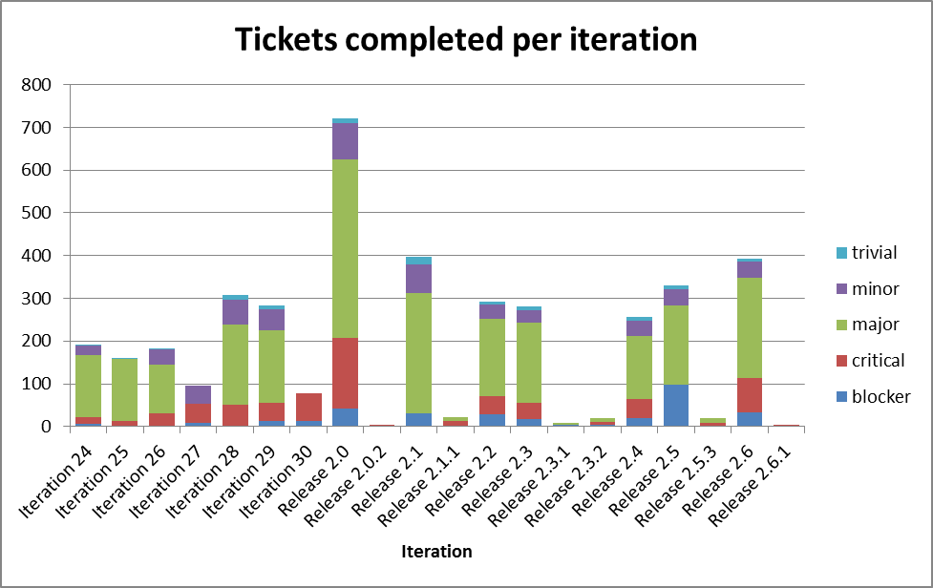
The Release 2.0 appears out of proportion beacause it covered two development iterations (6 months of effort).

Project Uptake

Mailing List Subscriptions
Our software download site no longer requires people to register to a mailing list in order to download the installer packages. A simple analysis of the email domains shows that while the majority of the users are from ISIS, followed by ORNL and we have had some interest from other institutions and universities.
Summary
Date | 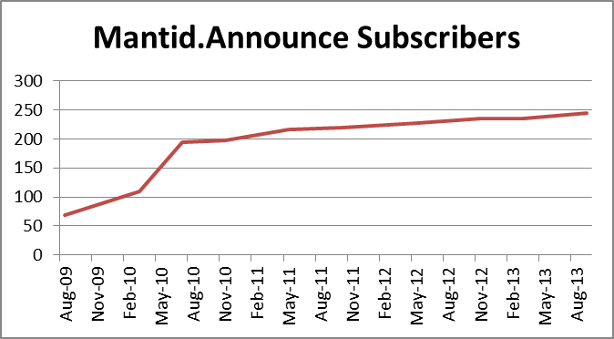  Users
Aug-09 | 68
Mar-10 | 109
Jul-10 | 195
Nov-10 | 197
May-11 | 217
Oct-11 | 219
May-12 | 228
Nov-12 | 235
Mar-13 | 235
Sep-13 | 245

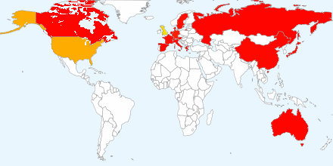
Current domain breakdown (2+)
Domain | count
stfc.ac.uk | 71
ornl.gov | 29
gmail.com | 22
helmholtz-berlin.de | 9
psi.ch | 3
swansea.ac.uk | 2
sheffield.ac.uk | 2
imperial.ac.uk | 2
caltech.edu | 2
esss.se | 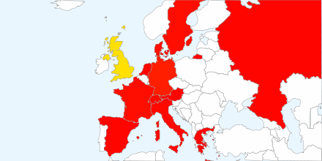  2
owlpic.com | 2
tudelft.nl | 2
ill.fr | 2
isc.cnr.it | 2
open.ac.uk | 2
physics.ox.ac.uk | 2
anl.gov | 2
bath.ac.uk | 2
uwstout.edu | 2
ansto.gov.au | 2
clemson.edu | 2
hmi.de | 2
ihep.ac.cn | 2
lanl.gov | 2

